Table of Contents
1. Introduction 2
1.1. Existing System 2
1.2. Need for the New System 2
1.3. Objective of the New System 2
1.4. Problem Definition 2
1.5. Core Components 2
1.6. Project Profile 2
1.7. Assumptions and Constraints 2
1.8. Advantages and Limitations of the Proposed System 2
1.9. Proposed Time Line Chart 3
2. Requirement Determination & Analysis 3
2.1. Requirement Determination 3
2.2. Targeted Users 3
3. System Design 3
3.1. Use Case Diagram 3
3.2. Class Diagram 4
3.3. Interaction Diagram 5
3.4. Activity Diagram 7
3.5. Data Dictionary 8
4. Development 10
4.1. Coding Standards 10
5. Agile Documentation 10
5.1. Agile Project Charter 10
5.2. Agile Project Charter 10
5.3. Agile Project Plan 10
5.4. Agile User Story ( Minimum 3 Tasks) 10
5.5. Agile Release Plan 10
5.6. Agile Sprint Backlog 10
5.7. Agile Test Plan 10
5.8. Earned-value and burn charts 10
6. Proposed Enhancements 10
7. Conclusion 10
8. Bibliography 11

Introduction
<Write one paragraphs about the document and one paragraph about the project focusing on the subject (i.e. the business) For example: In case of banking and credit cards, explain in a paragraph about the banking industry and how the business of credit cards are managed by the banks>

Existing System
<Explain the processes in the existing system. The existing system can either be automated or manual. The existing business processes along with a workflow diagram should be provided>

Need for the New System
<Explain the purpose of the new system by describe the challenges and limitations of the existing system in brief and hence justifying the need for a new system>

Objective of the New System
<List and explain the business objectives that the new system is expected to fulfill. The objectives may include performance enhancement of various business processes, reducing/eradicating information latency, simplification of tasks, enhancing process accuracy, etc. Remember that these objectives should somehow link and address the challenges mentioned in 1.2. (Need for the new system)>

Problem Definition
<Provide a brief description clearly defining the scope of the proposed system>

Core Components
<Elaborate the problem definition (as mentioned in 1.4.) by specifying various modules in the proposed system and explaining how each module would cater to the objectives of the new system (as mentioned in 1.3.)>

Project Profile
<Single page project profile as per the prescribed format>

Assumptions and Constraints
<Single page project profile as per the prescribed format>

Advantages and Limitations of the Proposed System
<Advantages: State how the proposed system would help the business to overcome the existing challenges (as mentioned in 1.2.). Limitations (if any): State the specific scenarios where the proposed system would not be able to function as expected or meet the business objectives (for example, if the system needs Internet connectivity to function which is not available in all condition).

Proposed Time Line Chart
<Provide a Gantt chart depicting the proposed timeline of the project>

Requirement Determination & Analysis

Requirement Determination
<Explain the way the requirements were determined for the proposed system (for example interview with stakeholders, focused group discussions, questionnaire, etc.)>

Targeted Users
<List the target users and state their roles in the proposed system>

System Design

Use Case Diagram
- Use case Diagram: Few points to remember
- First determine the system boundary-It is impossible to identify use cases or actors if the system boundary is unclear.
- Ensure that actors are focused-Each actor should have a single, coherent purpose. If real world object embodied multiple purposes, capture them with separate actor
- Each use case must provide value to the user.-Use case should not be defined too narrowly.
- Relate use case and actor-Every use case should have at least one actor and every actor should participate in at least one use case.
- Use case can be structured-For large use case we can fragment the use cases.
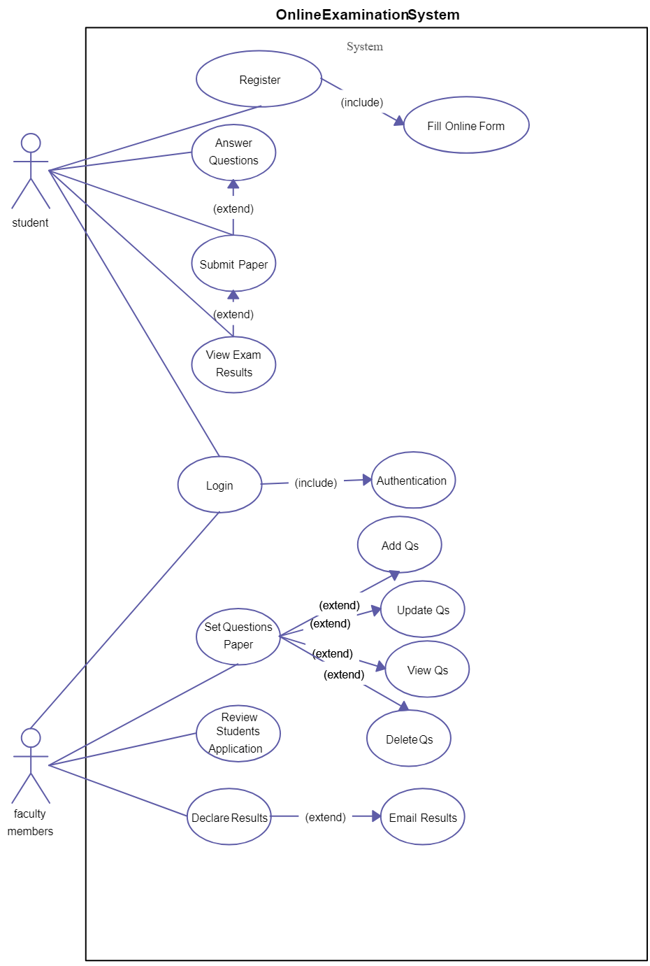

Class Diagram
Class diagram:- Few point to remember
- Scope-First step is to understand the problem to be solved.
- Simplicity-Strive to keep your model simple as it is easy to understand . Try to use minimal number of classes that are clearly defined and not redundant.
- Diagram Layout-Draw the diagram that elicit symmetry. Try to avoid crossing lines
- Name-Carefully choose the name .Name should be descriptive and unambiguous
- Multiplicity-At the end of the association place the multiplicity.
- Association end name- For multiple uses of the same class, use association end name.
- Generalization-Try to avoid deeply nested generalization.
- Reviews-Try to get others to review your models, expect that your model will require revision.
- Documentation-Always document your model.
- 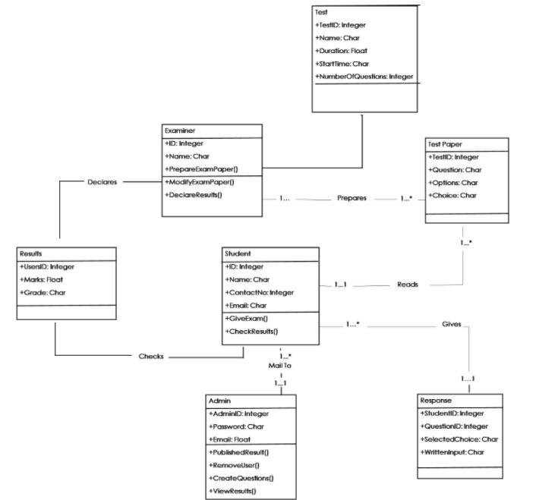

Interaction Diagram
- Interaction Diagram: Few points to remember
- Prepare at least one scenario per use case- For each use case there must be at least one scenario.
- Abstract the scenarios into sequence diagram- The sequence diagram clearly shows the contribution of each actor.
- Divide complex interaction- Break large interactions into their constituent task and prepare a sequence diagram for each of them.
- Prepare a sequence diagram for each error condition- Show the system response to the error condition.

Scenarios-
A scenario is a sequence of events that occur during one particular execution of a system, such as for a use case.
For the Use case 1 -issue credit card the scenario is as follow
Primary Actor : admin,student,faculty

Admin : get access to the system
Pre Condition: The main screen is displayed
Post Condition: System displays home screen
Main Success Scenarios:
  - Bank (User) Selects the menu customer A/c.
  - System displays all details of customers (id name, etc).
  - Bank verifies the details.
  - System displays verified successfully.
  - Bank sets a min. Credit amount.
  - Bank issues a card
  - System displays – Credit card issued successfully to a customer.
Exception:
- 3(a) Details not verified
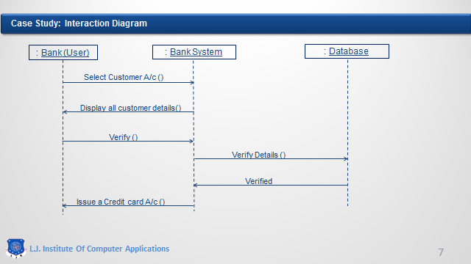

Activity Diagram

- Activity Diagram: Few points to remember
- Level diagrams- Activities on a diagram should be at consistent level of detail. Place additional for an activity in a separate diagram.
- Be careful with branches and conditions- If there are conditions, at least one must be satisfied when an activity completes .
- Be careful with concurrent activities- Concurrency means that the activities can complete in any order and still yield an acceptable result. Before a merge can happen , all inputs must first complete.
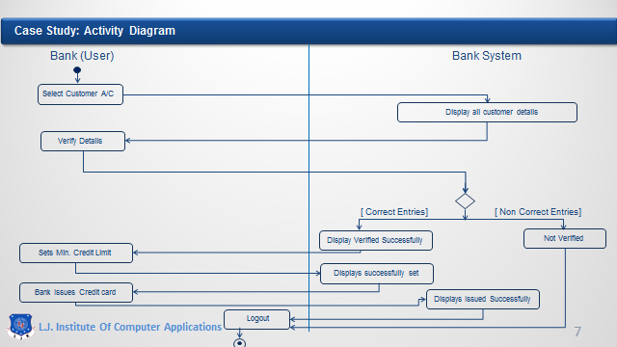

Data Dictionary
<Provide data dictionary of the designed database in the prescribed format. Also include an appendix to state the functional dependencies for each table and mention their normal forms>
Example:
Table Name: Admin
Table Description: Stores Details of admin
Sr No. | Field Name | Data Type  (with Size) | Constraint | Description | Sample Data
1 | id | Int (20) | Primary Key | Unique Id of Admin | 1
3 | email | Varchar (50) | Not Null | Email id of Admin | xyz@gmail.com
4 | mobile_no | Varchar (255) | Not Null | Mobile no of Admin | 1234567890
5 | username | Varchar (255) | Not Null | User Name of Admin | xyz
6 | password | Varchar (255) | Not Null | Password of Admin | *********

Table Name: Course
Table Description: Stores the basic details of each course offer by college

Sr No. | Field Name | Data Type  (with Size) | Constraint | Description | Sample Data
1 | course_id | Int (20) | Primary Key | Unique Id of Course | 1
2 | course_code | Int (20) | Not Null | Code of Course | 1001
3 | course_name | Varchar (20) | Not Null | Name of Course | MCA
4 | indicator_id | Int (4) | Foreign Key | Reference of Indicator | 1

Development
<Write a paragraph on the way development was conducted stating the process of distribution of work among the team members and the process of integration>

Coding Standards
<State the coding standards and naming conventions followed during development of the product>

Agile Documentation

Agile Project Charter

Agile Project Charter
General Project Information
Project Name | Examination System
Project Champion | Team Members name
Project Sponsor | Company name
Project Manager | Internal Guide name
Stakeholders | L.J Institute Of Computer Application
Expected Start Date
Expected Completion Date

Project Details
Mission
Vision
Scope

AGILE Road Map
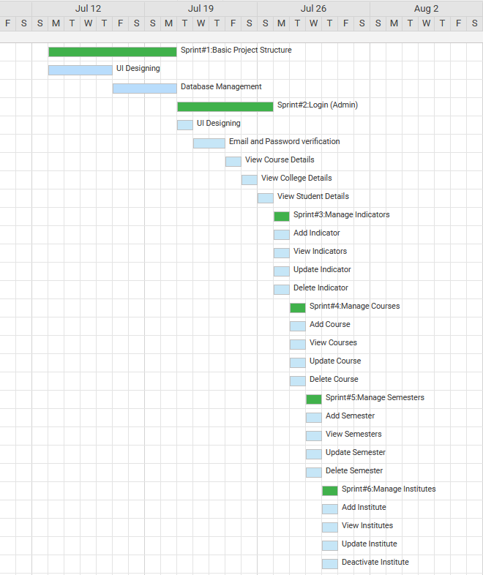

Agile Project Plan
Task Name | Duration | Start | Finish | Status
Sprint#2:Login (Admin) | 6d | 21-07-2020 | 26-07-2020 | Complete
UI Designing | 1d | 21-07-2020 | 21-07-2020 | Complete
Email and Password verification | 2d | 22-07-2020 | 23-07-2020 | Complete
View Course Details | 1d | 24-07-2020 | 24-07-2020 | Complete
View College Details | 1d | 25-07-2020 | 25-07-2020 | Complete
View Student Details | 1d | 26-07-2020 | 26-07-2020 | Complete

Agile User Story ( Minimum 3 Tasks)
User Story ID | As s(type of user) | I want to perform | So that I can(achieve some task)
¹ | ^{Admin} | ^{Login} | ^{Access My Account}
² | ^{Admin} | ^{Manage Indicators} | Manage Indicators For Course Indentification

Agile Release Plan
Task Name | Duration | Start | Finish | Status | Release Date
Sprint#2:Login (Admin) | 6d | 21-07-2020 | 26-07-2020 | Complete | 26-07-2020
UI Designing | 1d | 21-07-2020 | 21-07-2020 | Complete | 21-07-2020
Email and Password verification | 2d | 22-07-2020 | 23-07-2020 | Complete | 23-07-2020
View Course Details | 1d | 24-07-2020 | 24-07-2020 | Complete | 24-07-2020
View College Details | 1d | 25-07-2020 | 25-07-2020 | Complete | 25-07-2020
View Student Details | 1d | 26-07-2020 | 26-07-2020 | Complete | 26-07-2020

Agile Sprint Backlog
Task Name | Story | Sprint Ready | Priority | Status | Story Point
Sprint#1:Login (Admin) | Yes | Yes | High | Complete | 10
UI Designing | Yes | Yes | High | Complete | 8
Email and Password Verification | Yes | Yes | High | Complete | 8
View Course Details | Yes | Yes | Medium | Complete | 2
View College Details | Yes | Yes | Medium | Complete | 2
View Student Details | Yes | Yes | Medium | Complete | 2

Agile Test Plan
Project Name |  | Examination System |  |  | Device |  | HP intel core i3  7th gen
Test Case Id |  | 1 |  |  | Test Title |  | Send Enrollment Request And Accept It
Module Name |  | Student Enrollment |  |  | Tested By |  | Jainam Doshi
Priority |  | High |  |  | Execution Date |  | 19-08-2020
Test | Test Step |  | Action | Expected Result |  | Actual Result |  | Pass
1 | Click on ‘Send Enrollment Request’ |  | Open Enrollment Request form | Enrollment Request form should open |  | Enrollment Request page opened |  | Yes
2 | Upload Csv file and Click on Confirm button |  | Enrollment Request needs to be sent | Enrollment Request should be sent |  | Enrollment Request Not Sent.File must be xls or xlsx |  | No
3 | Upload valid excel file and Click on Add Enrollment Request button |  | Enrollment Request needs to be sent | Enrollment Request needs to be sent successfully |  | Enrollment Request needs to be sent Successfully |  | Yes
4 | Admin Click on View Enrollment request |  | Enrollment request list page must be open | Enrollment request list page must be open |  | Enrollment request list page must be opened successfully |  | Yes
5 | Click on Accept Button |  | Student Enrollment allocated | Enrollment Request Accepted successfully And student enrollment allocated |  | Enrollment Request Accepted successfully And student enrollment allocated successfully |  | Yes

Earned-value and burn charts
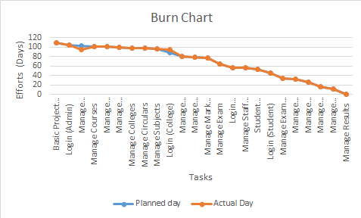

Proposed Enhancements

Conclusion

Bibliography

